**Section Three: Comprehension 20% (36 Marks)**

This section has **two (2)** questions. You must answer **both** questions. Write your answers in the spaces provided.

When calculating numerical answers, show your working or reasoning clearly. Give final answers to **three** significant figures and include appropriate units where applicable.

When estimating numerical answers, show your working or reasoning clearly. Give final answers to a maximum of **two** significant figures and include appropriate units where applicable.

Additional working space pages at the end of this Question/Answer booklet are for planning or continuing an answer. If you use these pages, indicate at the original answer, the page number it is planned/continued on and write the question number being planned/continued on the additional working space page.

Suggested working time: 40 minutes.

-------------------------------------------------------------------------------------------------------

**Question XX (18 marks)**

**Particle Physics — basic principles and techniques**

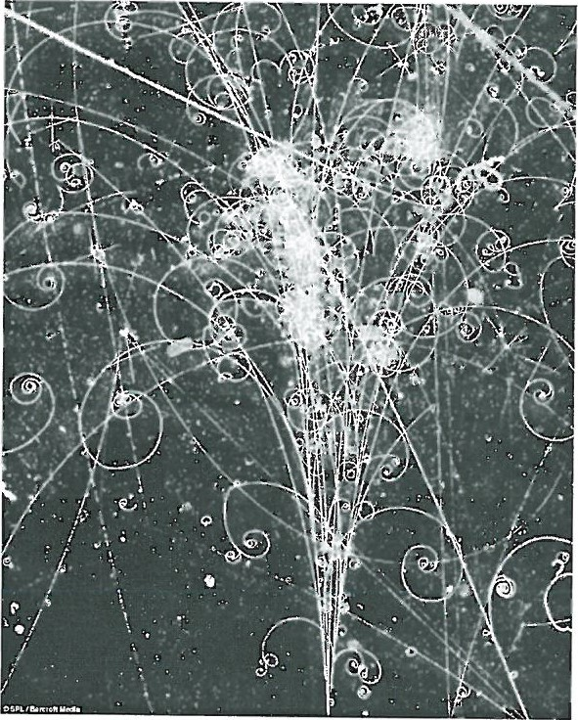Particle physics is the modern version of the age-old quest — to find the smallest particles that cannot be broken down. Particle accelerators are the 'laboratory equipment' in this area of study.

Charged particles can be accelerated in two senses - by their change of direction in circular paths or by increasing their speed. Studies can be made on the radiation that they emit whilst being accelerated or the after effects of collisions between high speed particles.

The cyclotron first came into use in 1928 using a combination of magnetic and electric fields to accelerate particles in a spiral path. Development of this technology led to the synchrotron which uses an evacuated circular tube with many magnets placed around its circumference.

As particles are accelerated the electric field is adjusted and the strength of the magnets is increased to maintain a constant radius and compensate for relativistic effects that become important at high particle energies.

Any charged particle that accelerates will radiate electromagnetic energy. This is true even at a constant speed in a circular path. So, a continual supply of energy is required in synchrotrons to just maintain a constant particle speed let alone increase their speed. The emitted radiation is known as synchrotron radiation and can cover the entire electromagnetic spectrum.

Linear accelerators (LINAC) use a straight path and a series of accelerating voltages as the particles move along the line. LINACs are often used to provide the early stages of acceleration before particles are fed into large synchrotrons.

Collider experiments take two beams of particles that have been separately accelerated in opposite directions and smash them into each other. This is difficult to achieve but if successful it is an efficient use of energy.

When two particles with an equal magnitude of momentum collide head on, the total momentum is zero before and after the collision. If particles are stationary after the collision then their kinetic energy is zero. By the conservation of energy and mass principle, the energy before the collision is transformed into the mass of new particles formed in the collision. The particles that are present after a collision reaction can be different to those that went in. This is exactly what particle physicists aim to achieve and the discovery and study of these new particles underpins their work.

Every collision is governed by one of the fundamental forces (except the force of gravity which has no significant influence on such tiny particles in this context):

* The **electromagnetic force** leads to simple collisions between charged particles. No new particles are formed when this force is at work.



* The **strong force** dominates reactions between hadrons (which contain quarks)



* The **weak force** is likely to be involved in lepton reactions, especially if one of the leptons is a neutrino.



Einstein's theory of special relativity has led us to the idea that the mass of a moving object is not the same as its rest mass (m0).

The mass of a moving object cannot be measured directly; it must be calculated from a measurement of momentum and velocity. The relativistic equations for momentum and total energy can be found in the Formulae and Data Booklet (Note: These equations are only applicable for non-zero mass)

Relativity has also given us the idea of mass-energy equivalence. In Newton's version of mechanics, a lone particle not influenced by gravity or electromagnetism but moving at a given speed could only have a single form of energy which is kinetic. At rest, it had no energy at all. This is not the case in relativity.

The relationship is described by the equation (EQ1) below

 (EQ1)

Photons are packets of energy travelling at the speed of light.

Surprisingly it has been proved that although photons have zero mass they do have momentum.

Particle physics has also proven to be vital in understanding the nature of the universe a few fractions of a second after the Big Bang. The conditions created in the mightiest accelerators are very similar to those that existed when the **universe was 1012 seconds old.**

(a) In what sense can a particle be accelerated if its speed remains constant? Explain. (2 marks)

(b) Once a charged particle has been accelerated to a given speed in a circular path, is further energy required to maintain a constant speed? Explain. (2 marks)

(c) Can electrons and neutrinos be subject to the strong force? Explain.

(2 marks)

(d) If neutrinos are involved in a collision reaction why is it unlikely that this was governed by the electromagnetic force? (1 mark)

(e) If you hit a ping pong ball with a table tennis bat which of the three fundamental forces described governs this collision? Justify your answer. (2 marks)

(f) Calculate the momentum of a proton travelling at 95% of the speed of light. The rest mass of a proton is given in the formula and constant sheet. (3 marks)

(g) Given the equation (EQ1) for Einstein's mass-energy equivalence, show that for a **particle at rest** the equation simplifies to E = **k**c2 where **k** is a constant. State clearly the physical quantity that **k** represents. (2 marks)

(h) From the equation EQ1, express the momentum of a photon with zero mass can be given **w**E where **w** is a constant. State clearly the physical quantity that **w** represents. (2 marks)

(i) Calculate the momentum of a photon of 550 nm yellow light. (2 marks)

**Question XY (18 marks)**

**The Physics behind the AFP Crime Scene Investigation**

Australian Federal Police have isolated **an element** found in a specimen at a crime scene. They suspect that the element may be sodium or potassium or unknown element **X** or **Y** and have asked the forensic laboratory to run tests on the crime scene specimen to identify which one element it consists of.

**The laboratory is able to ionise the element to give it a single positive charge.** They then accelerate the ions through a potential difference V (measured in Volts) and by use of a ve!ocity filter are able to send ions that have reached their maximum kinetic energy into a mass spectrometer. When the ions enter the mass spectrometer they are acted on by a uniform magnetic field and follow a semi-circular path.

Technicians conduct a series of tests and measure the radius **r** of circular motion for different values of potential difference used to accelerate the charged ions.

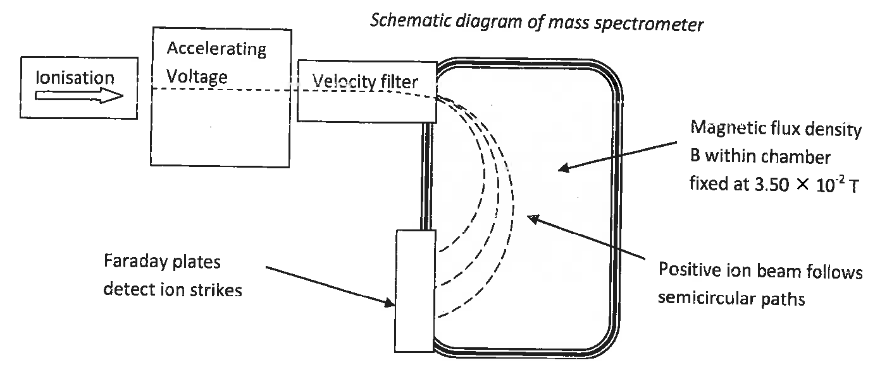

Table 1 (next page) shows the results obtained when the **magnetic flux density B** in the mass spectrometer was **fixed at 3.50 x 10-2 T.**

|  |  |  |
| --- | --- | --- |
| Potential Difference **V**  (V) | Radius of circular path **r**  (m) | Radius squared **r2**  (m2) |
| 200 | 0.270 $±$ 0.014 | 0.0730 $±$ 0.007 |
| 400 | 0.370 $±$ 0.019 |  |
| 600 | 0.490 $±$ 0.025 |  |
| 800 | 0.530 $±$**0.027** |  |
| 1000 | 0.620 $±$**0.031** |  |
| 1200 | 0.670 $±$ 0.034 | 0.449 $±$ 0.045 |

**Table 1**

It can be shown by an equation EQ2 on the Formulae and Data Booklet (that the radius **r** of circular motion for an ion of mass **m** and charge **q**, enters the mass spectrometer at speed ***v*** and being deflected by a magnetic field of flux density **B**.

(a) Use the equation EQ2 and other equations on the Formulae and Data Booklet

that link the kinetic energy in (Joules) attained by a mass of charge **q** in a potential difference **V** to **derive or show** that

**r2** = **gV** where **g** is a constant.

State clearly the physical interpretation (or quantities) that **g** represents.

(3 marks)

(b) Complete Table 1 by filling in the values of radius squared r2 with the appropriate uncertainty range. Two values have been done for you. (3 marks)

(c) Plot the data from Table 1 on the grid provided, demonstrating the relationship between radius squared **r2 (on the vertical axis)** and potential difference **V (on the horizontal axis).** Draw the line of best fit including error bars.

(5 marks)



(d) Calculate the gradient of your line of best fit from your graph showing all working. (3 marks)

(e) **Use the value of the gradient** that you obtained to **determine the identity** of the charged ion. (4 marks)

If **you could not obtain** a gradient from part (d), **use the numerical value of 8.00 x 10-4 for gradient.**

You may use the following data:

Mass of a potassium **K+ ion** = **6.49** x 10-28 kg

Mass of sodium **Na+ ion** = **3.68** x 10-26 kg

Mass of **X+ ion** = **7.84** x 10-26 kg ; Mass of Y+ ion = Not Available

END OF EXAMINATION